
Revision Techniques

Name_____________


UPLOAD, PROCESS, DOWNLOAD

Copyright for images in this booklet reserved to the original graphics creator. Only to be used for non-commercial educational purposes.
Why do we need to revise?

The brain requires a physical “prompt” in order to keep something in the long-term memory.
Otherwise, it is designed to let it go.
Your brain needs a prompt

What is cognitive load?
The working memory is where we process information and it is key to learning.

Cognitive load is the amount of information our working memory can hold at any one time.

How do we process information?

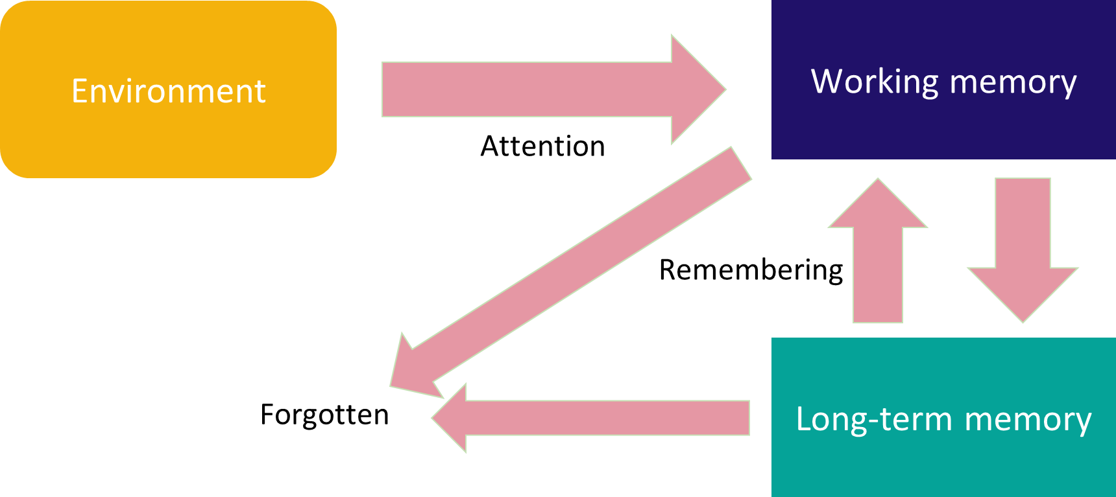
The capacity of our working memory is limited

What does this mean?
We must manage the ‘load’ of our working memory. We must maximise our working memory by practicing a range of strategies.

Preparing yourself to study

- Ensure you get a good night sleep. Try for a minimum of 8 hours
- Plan what time you need to wake up, set your alarm and eat a healthy breakfast
- Get fresh air
- Try to do some exercise each day. Maybe go for a walk for 15 minutes or play sports
- Set revision times for yourself and topics for each day
- Switch off digital devices when you are studying. Don’t have any distractions
- Eat healthy brain foods
- Drink lots of water and avoid sugary drinks
- Try different revision techniques
- Watch useful revision videos
- Attend revision sessions at school
- Try some of the revision strategies from this booklet

Preparing on the day of exams
- Check your exam timetable every day and know your subject and times for each exam
- Arrive early for exams
- Make sure your digital devices are handed in
- Double check your pockets to make sure you don’t have any revision notes in them
- Remove labels from bottles and only bring clear see through bottles to the exam location
- Only bring see through pencil cases to the exam location
- Know your seating plan – check your table formula in advance
- Leave your bags and coats in the hold area of the exam room or hall
- Use a black ink pen for all exam papers
- Write your first name and surname on all papers
- Write your candidate number on all papers
- Always read the instructions carefully
- Check how many marks are achievable for each question. This will give you a clue about how much information is required.
- Don’t leave any blanks, attempt all questions
- If you are stuck with any questions, leave it and move on. Make sure you go back to the question you left and try to answer it.
- Stay calm, don’t panic. You can do this.

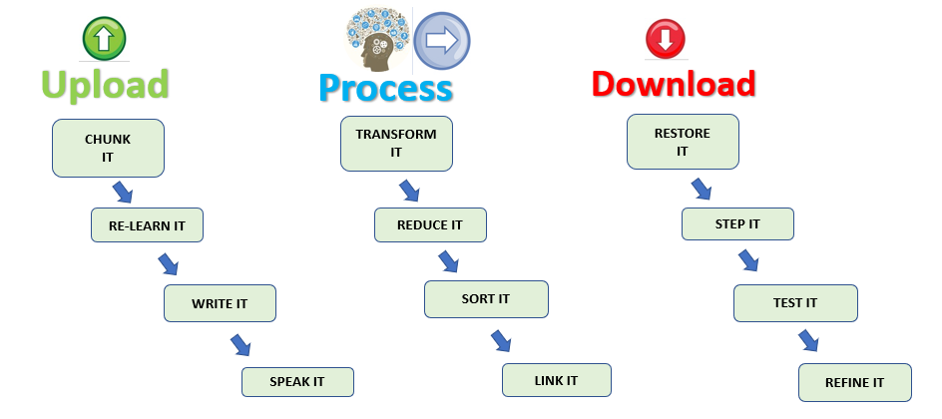

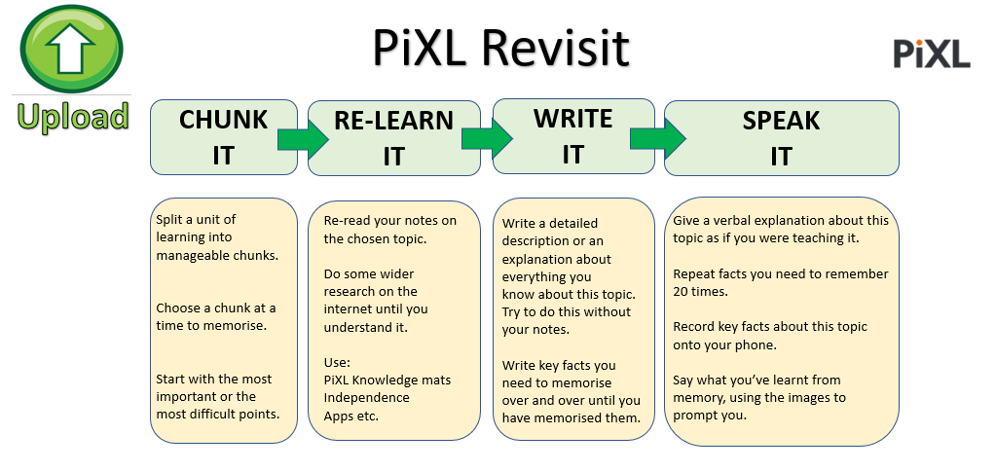

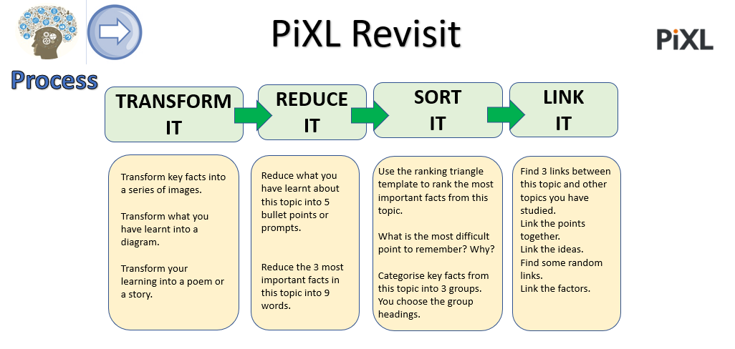

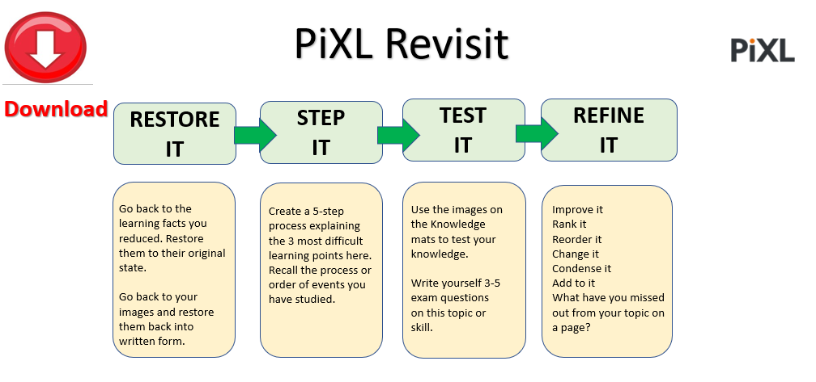

Revision Strategies To Try
Strategy | How it works | What does it look like?
Post-its | Write keywords or sentences on post it notes to help you make notes to refer back to. Stick them on doors, walls, note books or sheets of paper. You can group them or arrange them in sequence order or themes. | 
Favourite places | Stick revision notes and keywords in the places you often visit around the house so that you see them when passing and helps you remember again. Fridge door, shed, side of the TV, stairs | 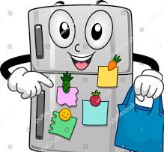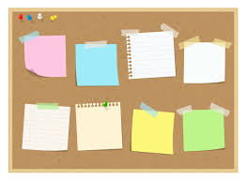
Revision/Flash cards | You can buy ready made flash cards or make your own. Write different keywords on each card. Shuffle the cards, then go through them quickly one at a time and try to explain each keyword to yourself or someone else loudly. | 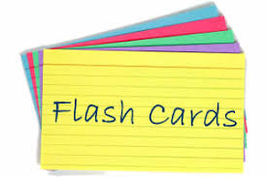  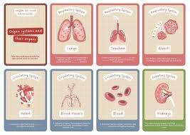
Mind Maps | Create a mind map on a topic to explore. You need to use paper or your note book. Landscape usually works better. Write the keyword in the centre. Draw branches coming out from the keyword and add images, symbols and other words that link. | 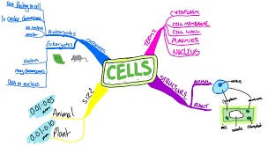
Spider Diagrams | This is a little like a mind map but instead, you can get your ideas jotted down about a topic ort keyword around the central word. Everything you think of can be written around like a web. You can develop this further into a mind map so that all your points link up into a branch. | 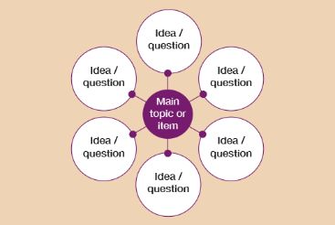
Use of colour | Our brains love colour and this helps us identify different things to help us remember better. Maybe all the important words can be in red. The descriptions in green, and a different colour for the drawings. | 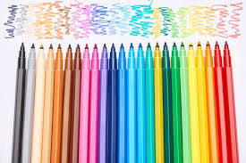
Concept Mapping | You can choose keywords, ideas, images, symbols or themes and write them on different cards, post it notes or pieces of paper. Then group them together to find the match and connections between them. Place them out and add arrows or lines to show where the connections are. | 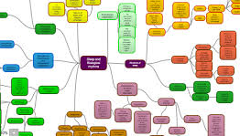
Underlining & Highlighting | Read through text and highlight or underline key concepts and keywords. You can then make a list of important words using this or use different colours to highlight different types of words. | 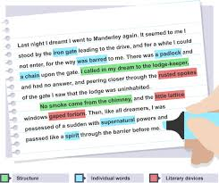
Teach Others | When you tell or teach others something, it increases our own understanding and helps us remember. | 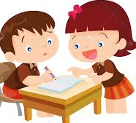
Mnemonics | There are two types you could try.  Using pictures:  Connect words with an image. This will help you remember the word by picturing the image.  First Letter Mnemonics:  With this technique, you use the phrase to help you remember the first letters of a sequence of key words. | 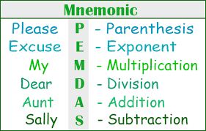
Tables | When we have lots of complex concepts to remember and revise, it helps by making category tables to divide these into. It could be advantages and disadvantages of something, it could be simplifying stages of a concept. | 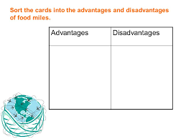
The Journey Technique | This method requires a journey you often make. For example, your commute to and from school. Each time on this route you see the same things, in your mind assign an image, keyword or concept to each location as a pair. The bus stop could be a certain keyword, the bus could be the description and the school gates could be the concept. Keep doing this in your mind so that when you are stuck, you think of this route and the answers will be in your mind when you think of the bus stop, bus and gates. |   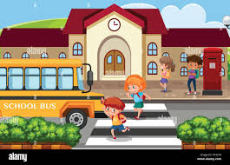
Make Lists | Either use a numbered or bulleted list to make a list of points for revision or words. Maybe make your own checklist for revision keywords in order so that you can tick them off as you revise. | 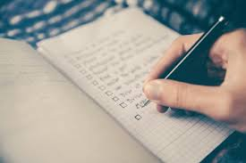
Weird Pairs | This method is about making a list of words that strangely pair up with another word for you to remember. That will pair up with the next and the next. They don’t need to make sense, they just need to make sense to you. For example,  1 = friend, 2 = lunch, 3 = cinema  You know you will meet your friend, have lunch then go to the cinema. Replace the words with something that makes sense to you that could link. | - Friends  - Lunch  - Cinema
Number Pairs | Try matching numbers that rhyme with keywords. For example, 10 = hen. Try using this to help you remember. | 10 = Hen  8 = Plate
Quizzes | Quizzes that are quick are fun and competitive. Try a mastermind round of hot seat questioning challenges or two player buzzer challenges, or timed quizzes. Quizzes are great for retrieval and you can keep trying them again and again. | 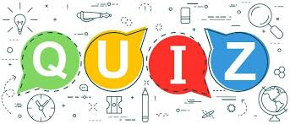
Sequence It | Go through your revision notes and put them into a logical sequenced order so that it is clear how things progress. | 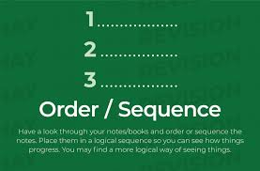
Group It | If you group your revision notes into topic categories or in sequenced order, it will help with identifying and revisiting key sections. | 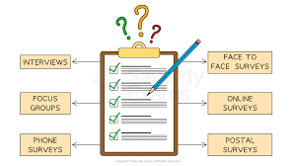
Posters | Design a poster of any size after reading lots of information an researching your chosen topic. This will help to simplify key knowledge in a visual and colourful way. | 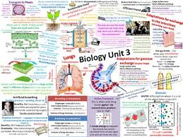
Visuals | Images are easier to remember than just text. Make use of drawings and create your own to help with revision. Instead of keywords, use people, ideas, colours, places and pictures. | 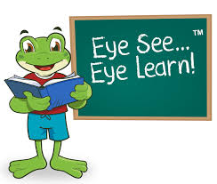
Spec & Syllabus | Access the spec or revision books for your qualification online or from your teacher. Check your notes against the spec. | 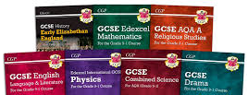
Gaps Problem Areas | Identify what you are good at and know well and identify what you need to revisit and learn further. This way you know what you need to focus on and make a plan for this. |   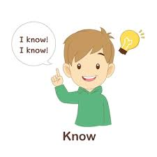
Questions & Answers | Make your own questions and answers to use with a friend or test yourself. Maybe make a game out of it with a few friends. You could all choose a topic to make the Q&A questions and answers to test each other. | 
Fill The Blanks | Write your notes again or copy from the revision book leaving some gaps for you to fill in later. You could even print a few off so that you can keep using them again. | 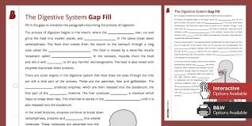
Abbreviations | Could you come up with a symbol or abbreviation for keywords? They will help you remember better when you use these instead of writing them as text each time. | 
Sing It | Create a rap or song around keywords and revision topics. Sing it out aloud to help you remember. Make it catchy! | 
Say It Loudly | Reading notes out loud helps you think deeper about what you are reading and will help you remember effectively | 
Deepseek AI  website | Create tabs using AI to condense revision notes for specific exam board specifications. | 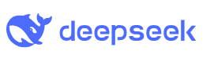
Gauth AI App | Take a photo of a question, the app will give you an explanation and a breakdown of the question with all the possible answers | 
Past Exam Papers | Most students say that using past papers helps them the most with improving exam performance. Try highlighting the questions using red, orange and green. Red for what you don’t know, orange if you need a little more revision on it and green when you fully understand it. | 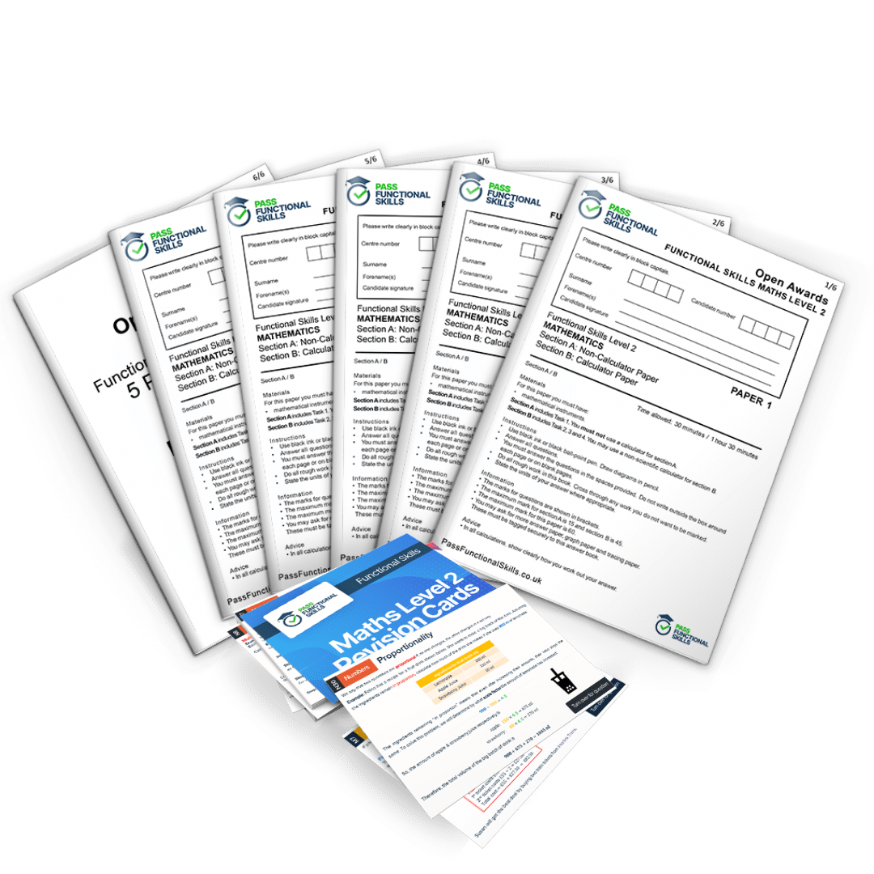
Look, Cover, Write, Check | Look through revision resources, cover it up, then write down what you remember. Check you didn’t include and add this on. | 
Pyramids | You have 2 sections to the pyramid. At the top, write the topic. In the middle, add the important facts. At the bottom, write down key technical language and specific information about the topic and facts. | 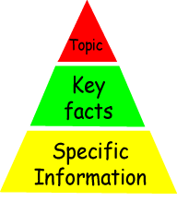

Key Command Words to Learn
In exam papers, you will see command words. The command words tell you how to answer the questions. Learn the command words below and what they mean.
State | Give a specific value, name or other brief answer without explanations.
Annotate | Add brief notes to a diagram or graph. Simplified notes to describe something.
Analyse | Look closely at the detail. Break it down in order to bring out the essential information, elements or structure. Identify parts, patterns and relationships, and interpret information to reach conclusions.
Justify | Give valid evidence or reasons to support an answer or conclusion.
Compare | This could be explaining the advantages and disadvantages. Write about similarities and differences about both or all of them throughout.
Explain | Write a detailed account including reasons and examples.
Describe | Give a detailed account or picture of a situation, process, event or pattern.
Discuss | Write a considered and balanced review that includes a range of arguments, factors or hypotheses. Opinions or conclusions should be presented clearly and supported by appropriate evidence.
Illustrate | Write examples that makes the point clear – examples could be figures, diagrams or drawings.
Summarise | Write about the main points in a brief overview.
Interpret | Explain the points or meaning in your own words.
Outline | Summarise and give the most relevant and important details and information. Write a brief summary of the account.
Evaluate | Make judgements about the ideas, works, solutions or methods in relation to selected criteria. Assess the implications and limitations.
Give | Present information which determines the importance of an event or issue. Provide the cause.
Define | Write the precise meaning of a word, phrase, concept or physical quantity.
Identify | Give an answer from a number of possibilities. Recognise and state briefly a distinguishing factor or feature.

Try the WILT method
W | What is required? | Look at the command words and think about what the question means…what key information do you need to include?
I | What will I need to include? | Break down what is really needed in the answer. List the headings and use these to prepare your answer.
L | How long will the answer need to be? | Look at the number of marks achievable. If it’s 1 or 2 marks, the answer doesn’t need to be long. If it’s more marks, cover different points and explain in detail to achieve maximum marks.
T | What type of answer do I need to provide? | Read the question carefully to help you understand if the answer needs to be a diagram, a calculation, essay, true or false tick boxes, algorithm, writing with justification.

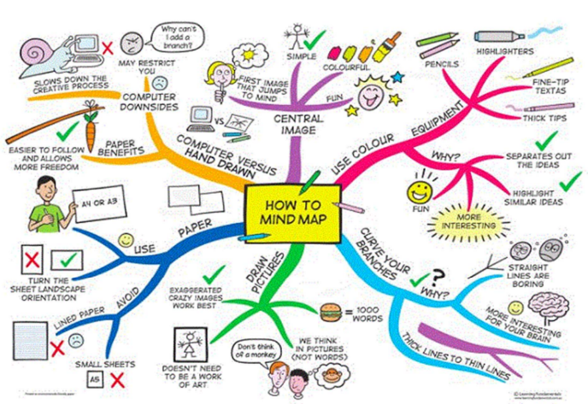
Examples of some revision strategies

Colourful mine map example taken from www.eastleake-ac.org.uk

Choose a topic and try expanding lines and branches of your own using the template from this book

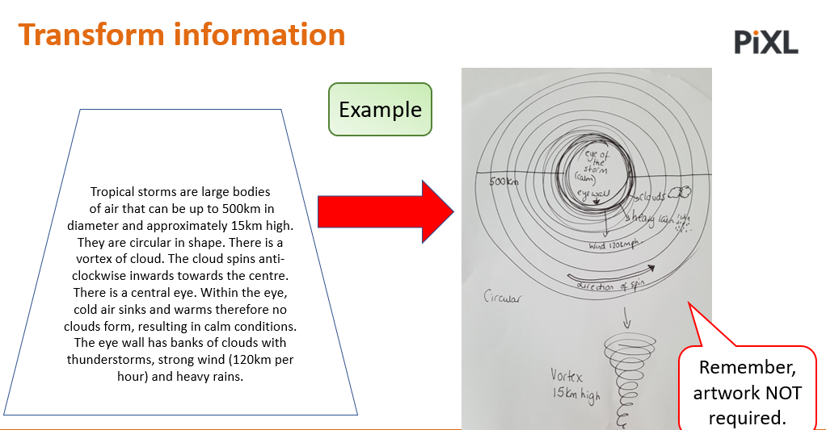

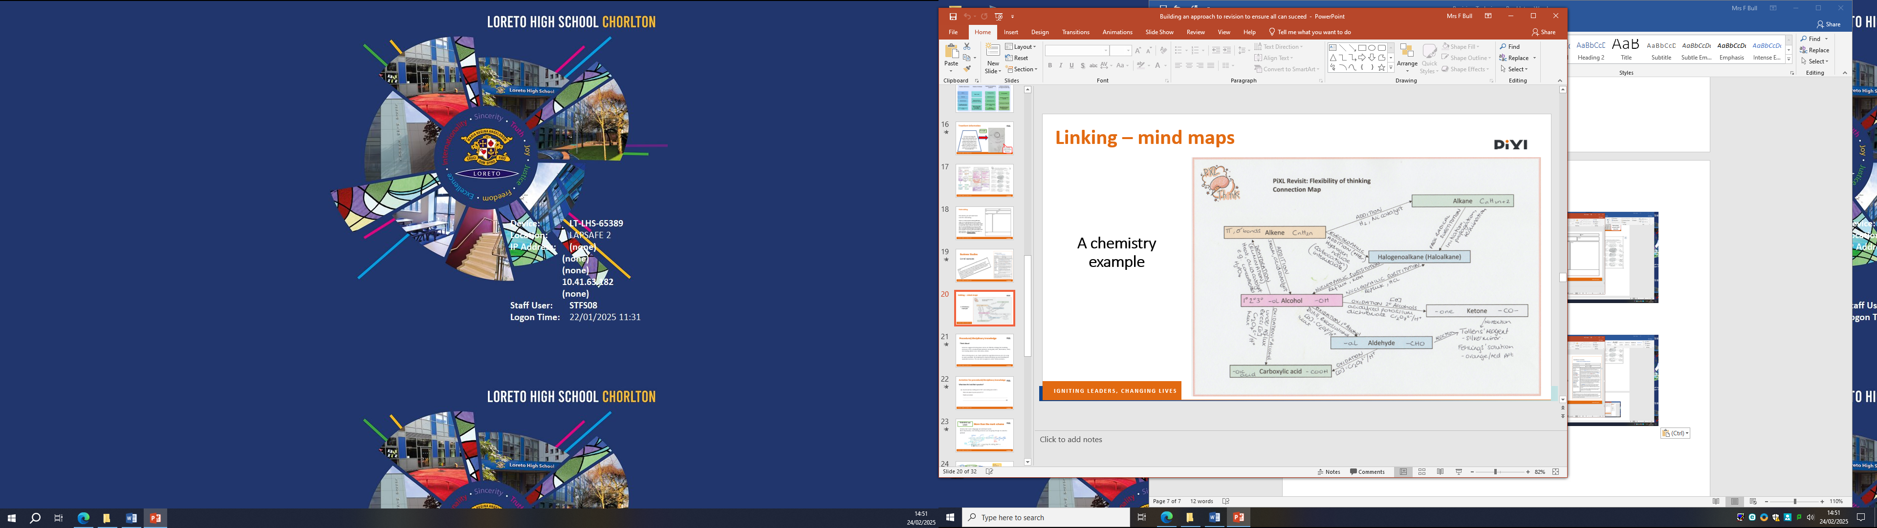
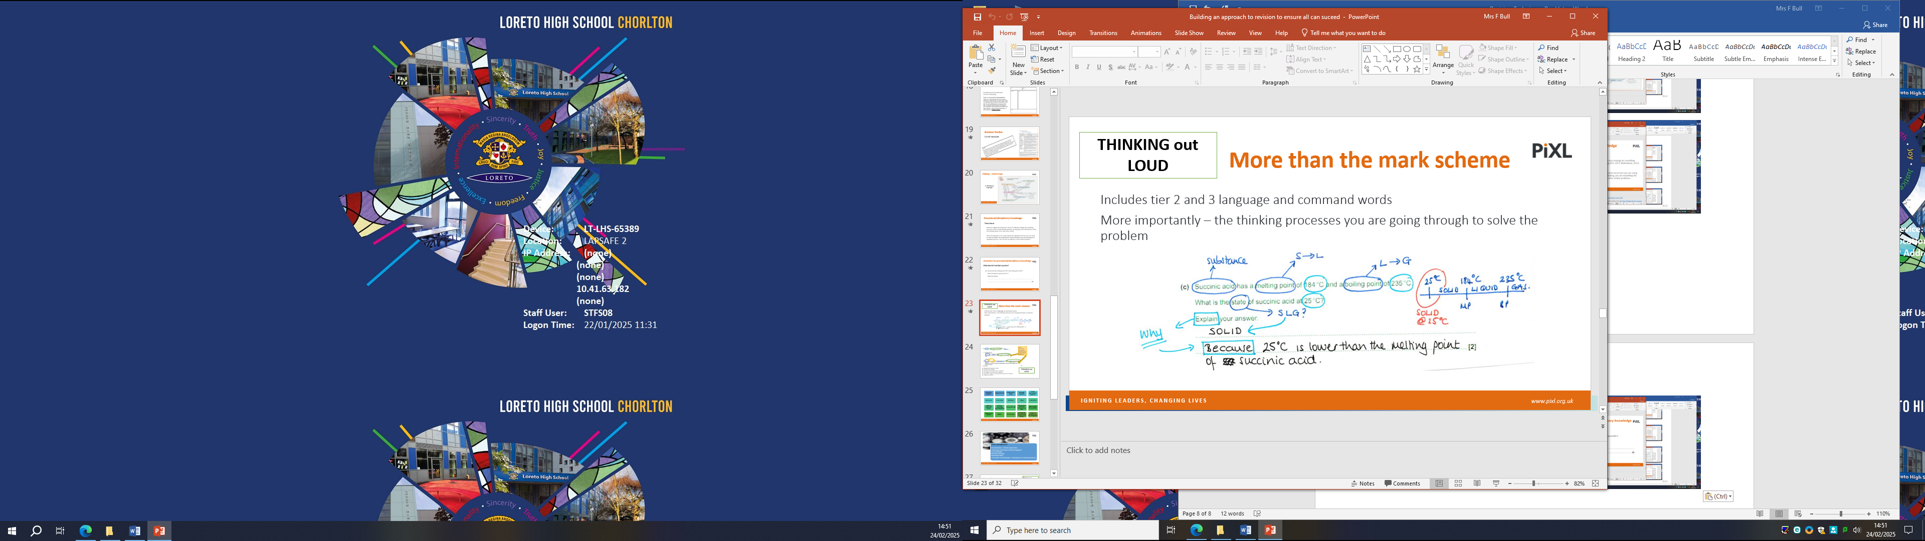
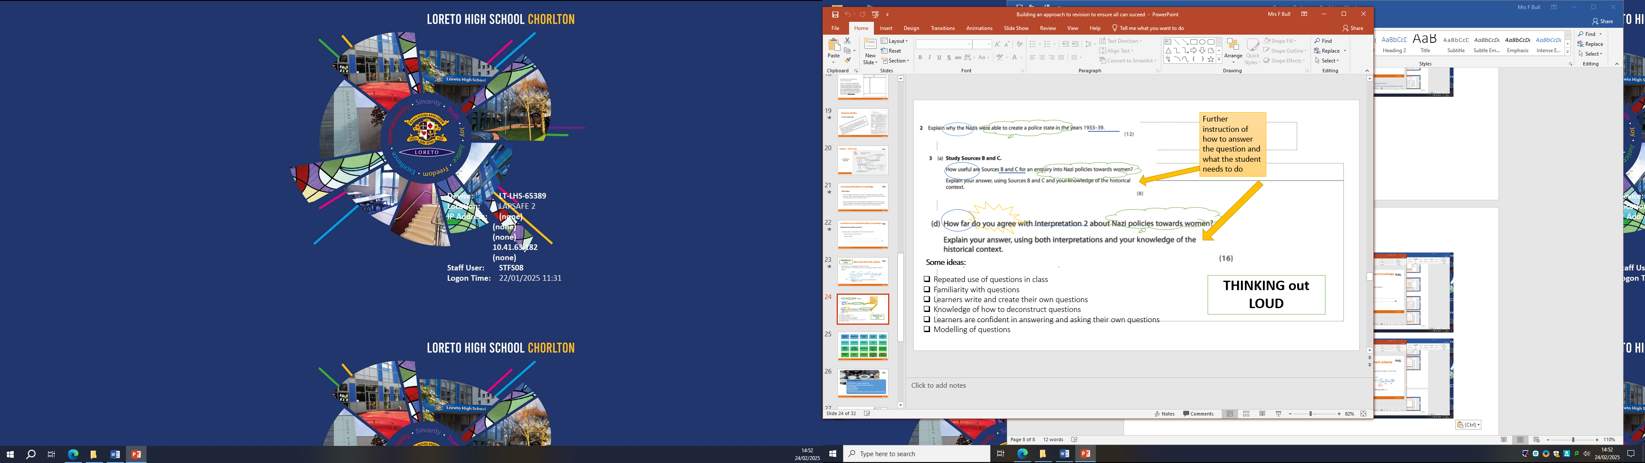

Example layout of chunking

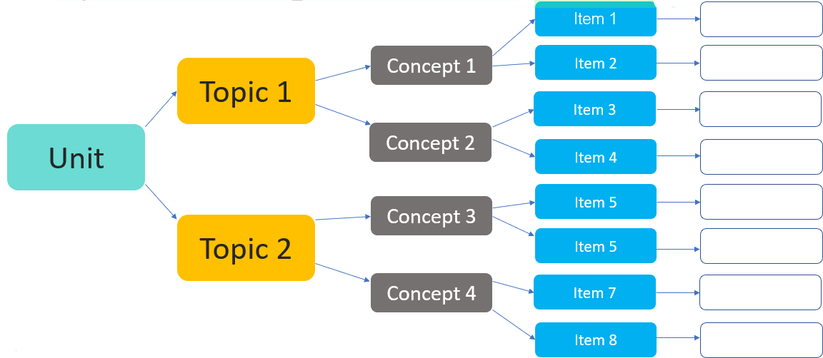

Now try your own

Revision Template – Mind Maps

